# Question 1:

I am predicting ADOS based on Verbal IQ, Non-verbal IQ and Social IQ, every time with a simple linear model.

I have not scaled the data, because the models had no problems converging.

Since my hypothesis (based on plotting the raw data) for all three models is the same (ADOS is negatively correlated with IQ), and since the output variable is the same and I have equally little information for all three predictors, I am using the same prior distributions for all parameters in the models.

The intercept for the linear relation between IQ and ADOS mean is a normal distribution with mean 15 and standard deviation 15. I have chosen a high ADOS value because of the negative correlation, and a high standard deviation to allow for the intercept to adapt to the data best.

The beta prior is sceptical, a normal distribution with mean 0 and standard deviation 5.

The sigma prior is a uniform distribution from 0 to 10, also fairly high.

## Verbal IQ

Here the raw data is plotted, with the linear model of the data (the mean relationship between ADOS and IQ) plotted with it. The small shaded area is a 89% highest probability density interval for the estimated means. The lighter grey area is the 89% probability interval for the ADOS values estimated by the model.

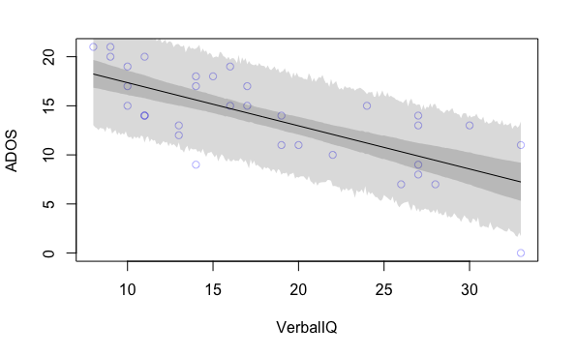

There is a negative relationship between ADOS and IQ, as predicted. The shaded region seems to capture the data distribution fairly well. There is higher uncertainty about the means at extreme IQ values, which is normal.

Here is a table of the most likely values for each parameter and their uncertainty. The beta value is reliably negative, between 0.3 and 0.55 decrease in ADOS for each increase of 1 in IQ. The intercept is high like predicted, but otherwise uninformative. The standard deviation is reliably between 2.5 and 3.8, fairly high. The intercept and beta are correlated, which was to be expected.

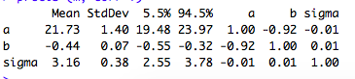

Model accuracy:

Here the ADOS values predicted by the model is plotted in red, along with the actual ADOS values in black. It can be seen that the model manages to predict the distribution fairly well, but underestimates the actual ADOS values, and has a misplaced peak.

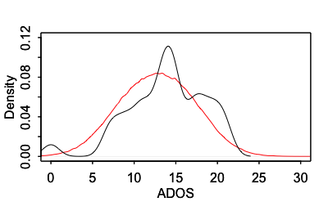

This is also clear from the plotted residuals below. Here it can be seen that there is a slight skew towards negative residuals, but that the residuals are otherwise distributed normally.

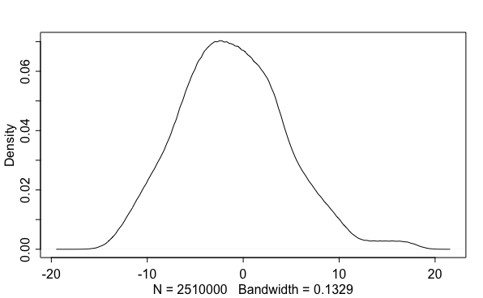

## Non-verbal IQ

Here the raw data is plotted, with the linear model of the data (the mean relationship between ADOS and IQ) plotted with it. The small shaded area is a 89% highest probability density interval for the estimated means. The lighter grey area is the 89% probability interval for the ADOS values estimated by the model.

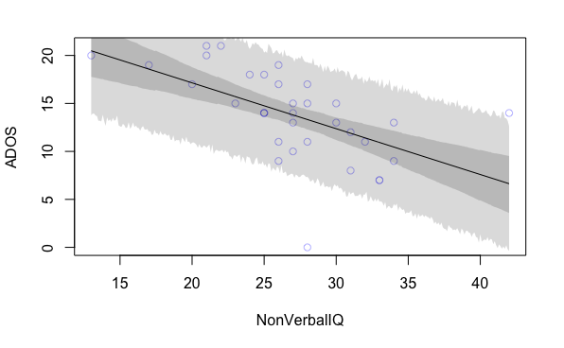

There is a negative relationship between ADOS and IQ, as predicted. The shaded region seems to capture the data distribution fairly well. There is higher uncertainty about the means at extreme IQ values, which is normal.

Here is a table of the most likely values for each parameter and their uncertainty. The beta value is reliably negative, between 0.3 and 0.67 decrease in ADOS for each increase of 1 in IQ. The intercept is high like predicted, but otherwise uninformative. The standard deviation is reliably between 3 and 4.5, fairly high. The intercept and beta are correlated, which was to be expected.

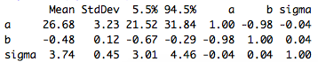

Model accuracy:

Here the ADOS values predicted by the model is plotted in red, along with the actual ADOS values in black. It can be seen that the model manages to predict the distribution fairly well, but that the predicted distribution is too wide, resulting in more extreme predicted values. It also seems slightly skewed towards underestimating ADOS values.

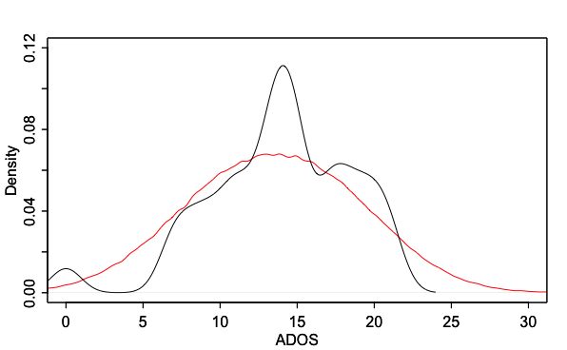

In the plotted residuals below, it can be seen that there is a very slight skew towards negative residuals.

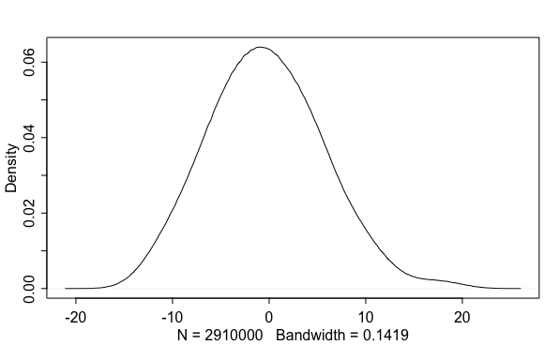

## Social IQ

Here the raw data is plotted, with the linear model of the data (the mean relationship between ADOS and IQ) plotted with it. The small shaded area is a 89% highest probability density interval for the estimated means. The lighter grey area is the 89% probability interval for the ADOS values estimated by the model.

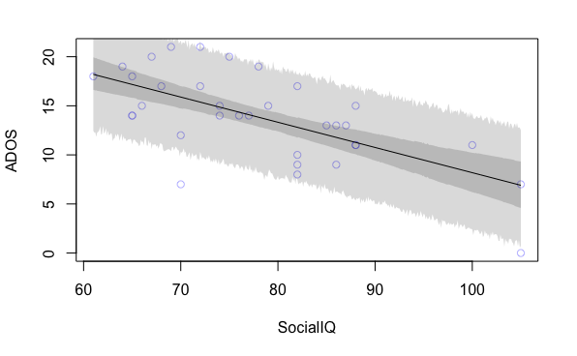

There is a negative relationship between ADOS and IQ, as predicted. The shaded region seems to capture the data distribution fairly well. There is higher uncertainty about the means at extreme IQ values, which is normal.

Here is a table of the most likely values for each parameter and their uncertainty. The beta value is reliably negative, between 0.2 and 0.35 decrease in ADOS for each increase of 1 in IQ. The intercept is high like predicted, but otherwise uninformative. The standard deviation is reliably between 2.7 and 4.1, fairly high. The intercept and beta are correlated, which was to be expected.

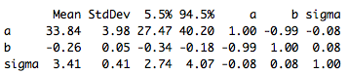

Model accuracy:

Here the ADOS values predicted by the model is plotted in red, along with the actual ADOS values in black. It can be seen that the model manages to predict the distribution fairly well, but underestimates the actual ADOS values, and has a misplaced peak.

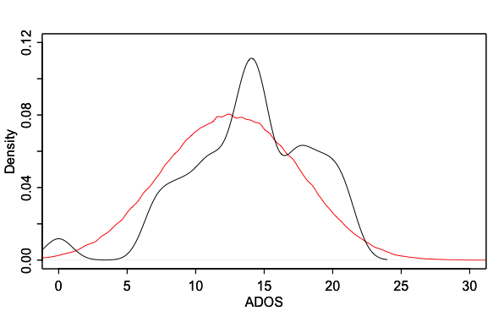

This is also clear from the plotted residuals below. Here it can be seen that there is a slight skew towards negative residuals, but that the residuals are otherwise distributed normally.

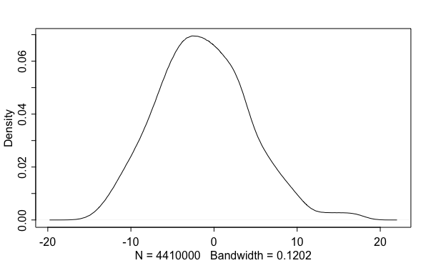

# Question 2:

From this task and onwards, the data for each predictor and for the outcome variable have been centered.  
  
The theory that there is a common intelligence level underlying the other kinds of intelligence would imply that the three types of intelligence are correlated. This would mean that we would not gain much new knowledge by including all three kinds of intelligence – when controlling for the other intelligence levels, any of them will perhaps be useless as predictors.  
On the other hand, this theory is not certain. It is also not certain that either of three predictors alone can capture all that is essential bout the common intelligence. Thus, it could also add valuable information to include all predictors, even though it will mean that the information I get, is only about the unique effect of each predictor, and not their whole effect.  
I will use all three in my model (in the order presented before). I am using same priors as before, but since the data has now been centered, the mean of my intercept distribution is now 0 (predicted to be equal to the mean of the population).

Below is the model output:

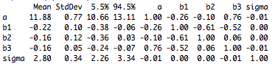

The mean of the intercept is positive, indicating that ADOS is higher than average when intelligence is average.   
All three predictors have negative correlations with ADOS, but the beta for nonverbal IQ has credibility intervals that are overlapping with zero. This reflects that the effect of nonverbal IQ is less certain, possibly due to shared variance between predictors. The effects of the other two predictors have also grown smaller.

It can be seen below that the model predicts better than the single predictor models did. Especially, it captures the high peak much better. It is now slightly positively skewed.

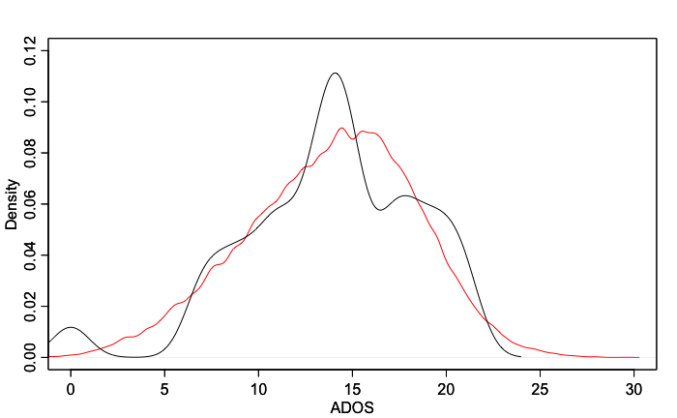

The residuals (plotted below) are very symmetrical around 0, indicating good predictions that do not greatly favour specific parts of the population.

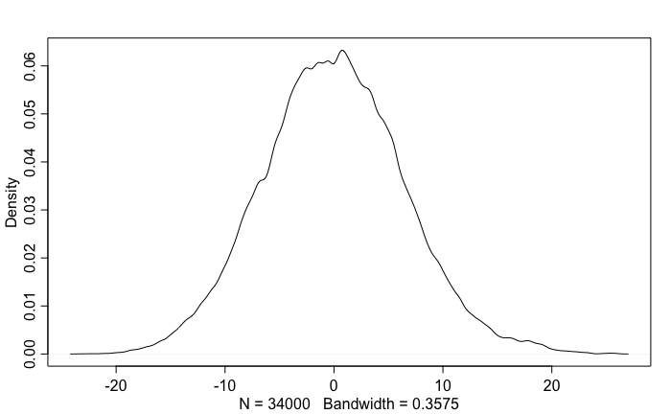

# Question 3:

ADOS is by definition very unevenly distributed among TD and ASD children. TD children all have a ADOS score below 5, and usually at 0, while ASD children can vary all the way to about 20. We will expect a bimodal distribution. The model is tuned to capture this, and, in the attempt to compromise, is bound to overpredict the effect of IQ for TD kids and underpredict it for ASD children – also leading to systematic mispredictions. Thus, it would overpredict the IQ of TD kids, and underpredict the IQ of ASD kids. Except for being inaccurate, this error may also have inequality-creating effect.  
  
I am using the same priors as before.  
The output of the model is seen below:

Mean StdDev 5.5% 94.5% a bv bnv bs sigma

a 7.14 0.47 6.38 7.89 1 0.00 0.00 0.00 0

bv 0.00 0.11 -0.17 0.17 0 1.00 -0.64 -0.47 0

bnv -0.09 0.14 -0.32 0.13 0 -0.64 1.00 0.25 0

bs -0.42 0.04 -0.48 -0.36 0 -0.47 0.25 1.00 0

sigma 3.96 0.34 3.43 4.50 0 0.00 0.00 0.00 1

The intercept is now a bit lower than before, but still positive. This still makes sense, indicating that ADOS is high when IQ is low. That it is lower before is already an indication that it may now be underestimating the higher ADOS values.

The credibility intervals of both verbal and nonverbal IQ now overlap with zero, rendering them uninterpretable.

Social IQ still is negatively correlated with ADOS.

Below is the predictive posterior and the observed outcomes: 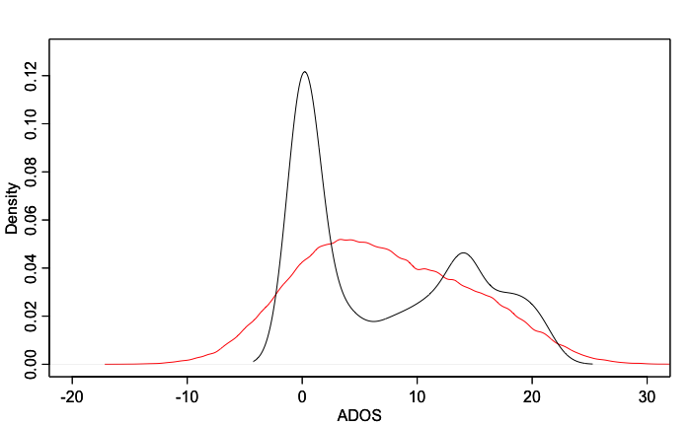

The bimodal distribution, and the models failure in capturing it, can clearly be seen. This means that the middle area of ADOS values between TD kids and ASD kids gets heavily overrepresented, and that the actual values (especially the TD kids) gets strongly underrepresented.

## Update:

I now added to the model a main effect of diagnosis and interaction effect with each of the three IQ’s. The model now gives the following output, numerical and plotted:  
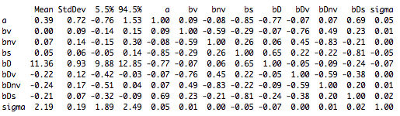

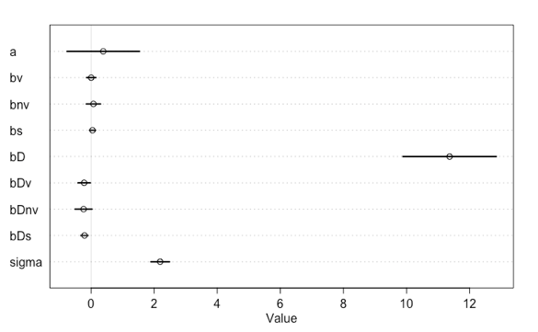

Where it can be seen that the main effects (that is, for TD children) of the types of IQ is now very close to zero, indicating that IQ and ADOS are not correlated for TD children. This makes sense, though, since there is a very negligible variation in ADOS for children who are not autist.  
There is also a large but trivial main effect of ASD diagnosis on ADOS.  
There also then seem to be a negative relationship between all three IQ’s and ADOS for ASD children, indicating that higher symptom severity is connected with lower intelligence.

The model is now also much better at predicting the data, because it can distinguish between the two subgroups of children.

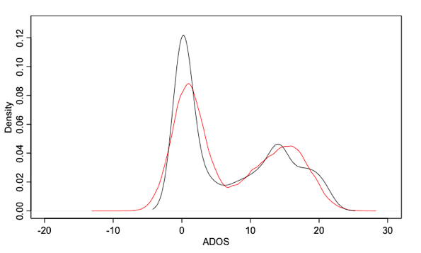

It can be seen how the model now is able to capture the two peaks for each of the two children groups.

# Question 4:

## 4.1

There seems to be shared variance between IQ’s. All the parameter estimates got closer to zero when more models were included, and nonverbal IQ even had credibility intervals overlapping with zero. They are also correlated in the precis output, both for TD and ASD children. Thus, it would seem that the different kinds of IQ are connected, although most clearly for ASD children (because there is very little variance to explain for the TD children).   
It is difficult to know if this is because all the IQ’s are facets of a single, common intelligence or if it is simply because they are all correlated with other factors (demographics, gender etc.).

## 4.2

Why are the different kinds of IQ correlated with lower ADOS? Possibly, the ADOS scoring by definition captures some phenomena resulting from low IQ. It is also possible that the deficits causing ASD also has an effect of IQ – possibly the common IQ. A lowered common IQ could indeed be the reason for all the symptoms of ASD. It is also possible that ASD, directly or indirectly, prevents the kids from learning or increasing their IQ, or that both measures are affected by the same underlying phenomena (like communicative ability).